ERP Management System Implementation in Educational Institutions: A Comprehensive Framework for Academic and Administrative Digitization
Sivakumar Dhandapani¹, ²Vijay K, Raghul G, Thahseen Kader Beevi A S, Akash K.
Professor & Head, Department of Computer Science and Engineering, AMET University, Kanathur, Chennai – 603112, Tamil Nadu, India.
EMAIL ID: hodcse@ametuniv.ac.in
Undergraduate Student, Department of Computer Science and Engineering, AMET University, Kanathur, Chennai – 603112, Tamil Nadu, India. EMAIL ID: erpcse2025@gmail.com

Abstract
The implementation of an ERP (Enterprise Resource Planning) management system at AMET University was a big step for handling all the academic and administrative stuff digitally. AMET is a specialized university for maritime and engineering., it deals with a lot of unique challenges like regulatory workflows and complex data across different departments. Before this, everything was fragmented, with manual processes causing delays and errors in things like approvals and reporting. Worked on integrated workflow automation, data management, and databases, to make data flow smoothly. There were web and mobile portals that allowed administrators, instructors, and students to access data in real-time. Generally, it improved accuracy, transparency, and satisfaction by addressing admissions, tests, finance, HR, research, and student services. This setup could be a model for other schools wanting digital transformation, modernizing operations and making management more sustainable with tech.
Keywords: Data Security, Scalability, Human Resource Management, Campus Portal, Communication, Multi-Campus Administration, Cloud-Based,

Introduction
Nowadays in universities, there are tons of data on students, faculty, money, exams, research, and compliance rules in the past and present. When handled separately, it leads to duplication, delays, coordination problems, and bad reporting. At AMET University, they saw this and started a digital mission with a custom ERP system to fit for their management. The university has class, labs, departments, regulatory units, and offices, each with their own old record systems causing inconsistencies and no unified info for decisions. The goal was to centralize all the process into a single, transparent, role based digital application.

Need for ERP Implementation in AMET University
The need of a ERP system came from several issues that will be solved with few changes from the existing module such as:
- Manually uploading everything would always lead to errors, delay, and loss of university data knowledge.
- There is a lack of real-time information, particularly concerning students’ performance, attendance, and financial transactions.
- Exams, admissions, fees, allocation, and other administration-based modules required so much work to be done.
- Challenges in maritime regulation compliance, which entail record accuracy and data submission.
The ERP system was supposed to mitigate the drawbacks mentioned by using automation, centralization, and data-driven decision-making.

Literature Background
The number of educational institutions that have adopted ERP solutions is on the rise, and the new systems of governance that are based on data have increased productivity and transparency. Studies conducted in various places have shown that centralization of data, removing of duplications, and streamlining of processes such as admissions, examinations, and student management have been the achievements of ERP systems in the educational sector. When such is done, the reporting accuracy is improved, and along with it real-time governance.
3.1 Existing System
The existing system are of web based or have a limited features in mobile application, which results in poor portability and it make it hard to login in every time in a browser. It also lacks a LMS(Learning Management System) without that every study materials are either given in hardcopies or in photocopies, which sometime end with someone losing their materials, and it also have a real-time process, where it will take few some time to go through the server, process there and update its data. Legacy ERP also had a major drawback that is its old firewall, those are easy to break it and have a big security related issue.
3.2 ERP Benefits in Higher Education
Nevertheless, the research has also pointed out that Being more efficient is one of the effects of an organization opting for ERP system as it leads to less paper work and better utilisation of the resources. The Integrated University Management Systems (UMIS) are intended to ensure that a single data base is available for the management of students, finances, human resources, accommodation, and library functions of an academic institution and thus encourage departmental cooperation.
3.3 Critical Success Factors (CSFs)
High-Level Support Among different studies, there is consensus on the fundamental factors that make the implementation of ERP in universities very successful. These factors are the presence of high-level support in the university, appropriate project management, involvement of stakeholders, good management of data quality and proper training of university staff. Also, the change management aspect in ERP implementation in university settings includes, among others, the change resistance and university staff being different kinds of users in the university. The lack of adequate training and ineffective communication are quite.
3.4 Challenges in ERP Deployment
There are still some problems for the higher education institutions to adopt ERP solutions. Among these are the adaptation necessities, the integration of legacy systems, and the costs. The institutions have also to deal with the variety of their numerous processes. In addition, they have to go through the difficult migration of data, the dependency on software vendors, and the lack of post-implementation support.
3.5 Security, Data Governance, and Quality Assurance
Therefore, in highlight that data governance is critical for the successful operation of ERP systems. If data quality is compromised, decision-making will suffer; moreover, lack of proper authentication can lead students' personal data being hacked. To be reliable, institutions must implement role-based access control, promote auditing, use encryption, and conduct data quality checks on a regular basis.

Methodology for ERP Development and Deployment
4.1 Requirement Study and Process Mapping
The process of building the project began with a meeting involving faculty, administrative staff, and maritime officials. The main objective of the meeting was to examine closely how each department manages current university systems to ensure effective operation. By mapping out these workflows, the team identified exactly where delays were occurring and how to bridge the gaps between different departments, namely students, faculty, the Head Department, and Administration.
4.2 System Design and Workflow Engineering
This system was designed to be both organised and flexible with the focus on four main goals:
• Creating a single, shared database so that all the modules has access to the same information and are interconnected. Setting up authentication and secure access levels so that they only can have access to see what is relevant to their roles so the work gets more easy & less messy. • Collecting and maintain how data is collected across all academic schools for better monitoring. Automating approval steps to move paperwork along faster digitally.
4.3 Module Development
Each module was designed as a unit capable of functioning autonomously while connecting and communicating with other components of the ERP system. This ensured flexibility in deployment without disrupting the already existed operations.
4.4 Testing and Quality Validation
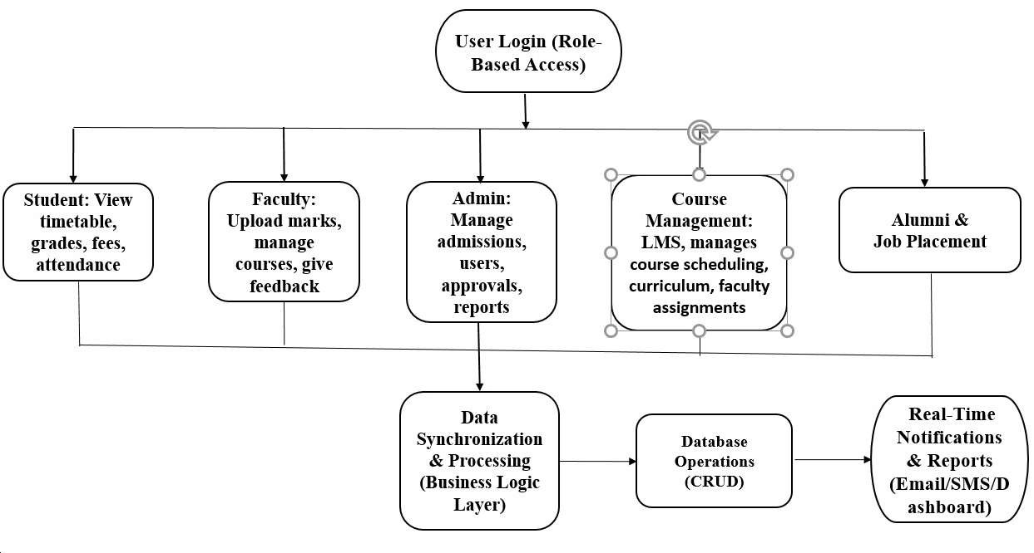
Before the deployment, the system went through three rounds of testing: functional testing, integrated testing, and user acceptance testing by checking the basic functions, seeing how the different modules are connected and integrated to each other, and finally letting the actual staff try it out. The developers used that feedback to fix bugs and make sure that the software is easier to use.
📊 Figure 4.1: Structure of the ERP Management System
5. ERP Modules: Faculty and HOD Implementation (Expanded Focus)
5.1 Faculty Module - Comprehensive Implementation
The Faculty Module is what teachers use every day. It puts all the school things in one place on the computer. The Faculty Module helps get rid of paper work and makes things easier for teachers. This means teachers have time to teach and less time doing paperwork. The Faculty Module is good because it helps teachers do their jobs better and it is still fair, for the students. The Faculty Module is really important for teachers to use every day
Key Functional Components
Attendance Management System:
Faculty members can see their classes on a dashboard. They mark if a student is present or not. When they do this the attendance information is available to the students the faculty members and the Heads of Department, at the time. The school does not have to keep attendance records so it is easy to see who is attending classes.
Assessment and Marks Management:
The module helps teachers put grades for tests and assignments in an organized way. It calculates scores on its own. Makes reports that show how students are doing. This means there are mistakes when putting grades into the computer. Teachers can see how students are doing all semester long and find out if some students are having trouble. They can then give these students help.
Leave Management Workflow:
Faculty members can send in their leave requests on the computer. They have to say how long they will be gone and why. These requests go to the Head Of Departments computer so they can look at them and say yes or no right away. The system keeps track of all the leaves and the people in Human Resources and the administration office can see them. This way of doing things on the computer made it so that leave requests can be approved faster it used to take 48 hours but now it only takes 12 hours.
Class Schedule and Timetable Management:
The module shows us the class schedules and the subjects that are assigned to each class. It also shows the teaching timings. We get updates away if there are any changes made by the administration. This way the faculty and the department have the schedule. The faculty can plan their time better because they can see the schedule information, for the module. The module is really helpful for the faculty to manage their time with the class schedules and the teaching timings
Faculty Module Impact: Quantitative Results
The Faculty Module delivered substantial improvements in academic operations:
- Attendance and Assessment Efficiency: Digital attendance marking and assessment entry reduced processing time by 60% compared to manual methods
- Leave Processing: Automated approval workflows reduced leave approval time from 48 hours to 12 hours
- Error Reduction: Digital entry and automated validation reduced administrative errors by approximately 85%

5.2 Head of Department (HOD) Module - Comprehensive Implementation
The HOD Module is like the office that connects all the different faculty operations with the people in charge of the university. The HODs are responsible for making sure the academic quality of their department is good that the faculty members are doing their jobs well that the students are learning what they need to and that everything is done according to the rules. The HODs also play an important role in communicating between the faculty members and the university administration. They are the ones who make sure everyone is working together and that the HOD Module is running smoothly. The HOD Module and the HODs are essential, to the university.
Critical Functional Components
Faculty Management and Oversight System:
The heads of departments get to see everything that is going on with the teachers schedules how often they are attending classes. How well they are doing in the classroom.
The heads of departments can look at boards that show them what the teachers are doing at any given time
Leave Request Processing and Approval:
The faculty leave requests all go to one place. It is easy to look at them and make a decision right away. When a request is approved it automatically updates the records that the Human Resources department and administrators use. This means that people do not have to update everything, which helps prevent problems with the schedule that can happen when someone is absent, without approval. The faculty leave requests system keeps a record of all the decisions that are made so it is easy to check that everything is being done correctly and follow all the rules.
Attendance and Academic Performance Monitoring:
The Heads Of Departments can see how many students are attending classes and how well they are doing in their studies at any time. If the Heads Of Departments notice that some students are not attending classes or are not doing well in their studies they can start programs to help these students. The Heads Of Departments can also look at how all the students, in the department're doing and see if there are any patterns. This helps the Heads Of Departments to change what they teach and how they teach it to make sure all the students are doing their best.
Timetable Management and Workload Optimization:
The module helps Heads Of Departments create timetables for their departments. It also lets them approve schedules and make sure that the work for the faculty members is divided fairly. The module uses algorithms to balance the workload. These algorithms make sure that no one faculty member has to teach much. They also help use the classrooms in the way possible and make sure that all faculty members get the resources they need.
Assessment Verification and Quality Assurance:
Faculty members submit the marks through the system. The Head of Departments reviews the Faculty members marks. Approves the assessments before they are sent to the examination offices. This is an important step to make sure the marks are correct. It helps to find mistakes in the calculations. It also makes sure that the grading is consistent for the Faculty members assessments

6 Challenges Encountered
Moving to a digital system was not easy task at first, there are few issues we face by this process:
- Resistance to Change: Many faculty members were used to doing things by hand and were hesitant to switch to a new way of working.
- Different Workflows: Each department had its own way of doing things, so ERP system needs to be customised to fit everyone's specific needs.
- Learning Curve: We had to provide training to faculty and administrators to make sure they feel comfortable and capable of using the new digital tools.
- Data Security: Protecting everyone's information and keeping the system safe from cyber threats was a top priority.
- Old Systems: We had to figure out how to work smoothly with the older systems from the university to enhance into new versions.
By offering regular training to work with our project and updating our policies by listening to staff feedback, we were able to overcome the issues faced and get everyone on board.

7. Results and Outcomes

7.1. Attendance and Assessment Efficiency Before implementing the ERP system, attendance and assessment management were done by hand, taking up a lot of time. After we put in the Faculty Module, recording attendance and entering marks became entirely digital. This cut the time needed for managing attendance and assessments by more than 60%.
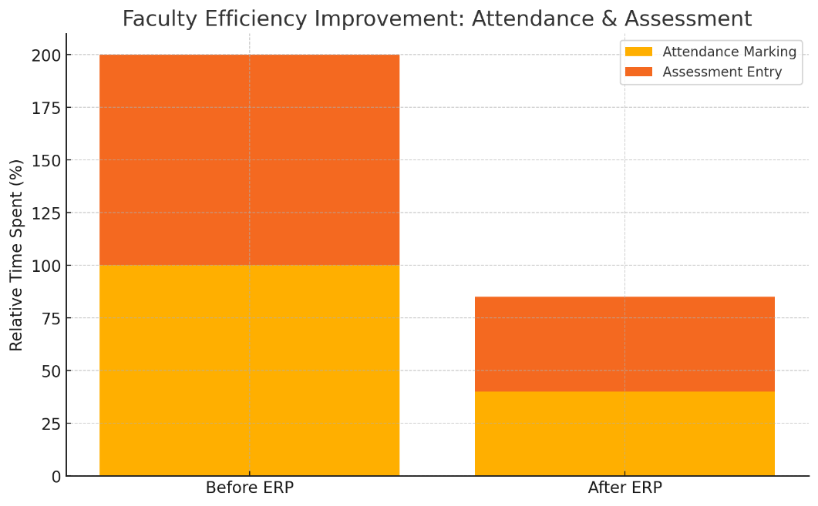

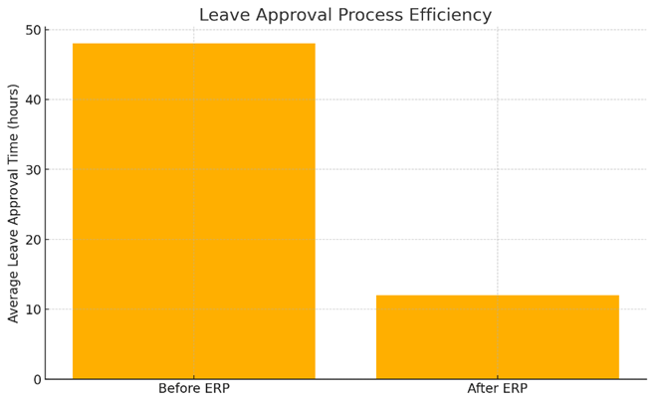
7.2. Leave Management and Approval ProcessThe earlier process required handling leave applications with paper forms. This sometimes caused delays. Now, a digital workflow combines the Faculty and HOD modules and automates the process. Faculty members can apply for leave online, and HODs can approve the applications directly from their dashboards. This change has reduced the average time for leave approval from 48 hours to 12 hours..

7.3. Academic and Departmental Monitoring

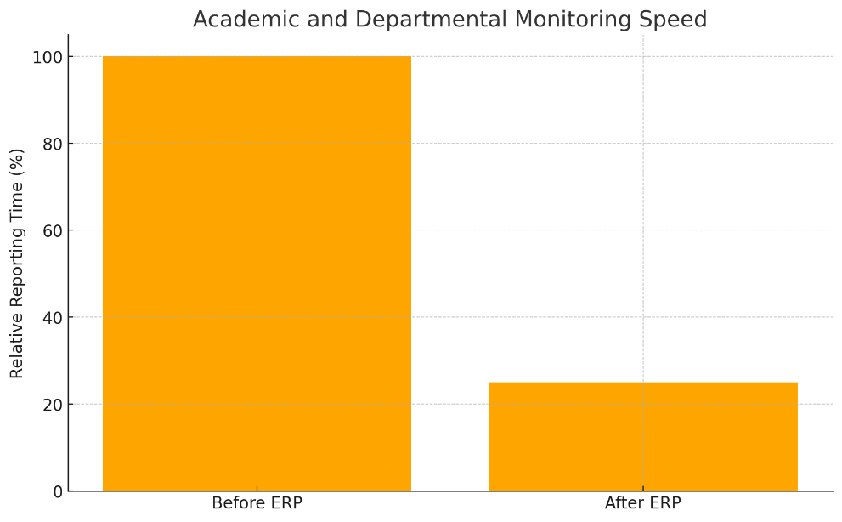
The HOD Module provides real-time visibility into attendance summaries, faculty workloads, and assessment progress. The integration has reduced reporting and monitoring time by 75% and has made data consolidation and academic monitoring faster..

7.4. Accreditation and Reporting Readiness

One of the major benefits of the ERP system is in relation to its impact on the preparation for accreditation. In the past, the process of compiling data from various sources would take as long as 72 hours. However, with the new system, this can be accomplished in 30 minutes (0.5 hours).
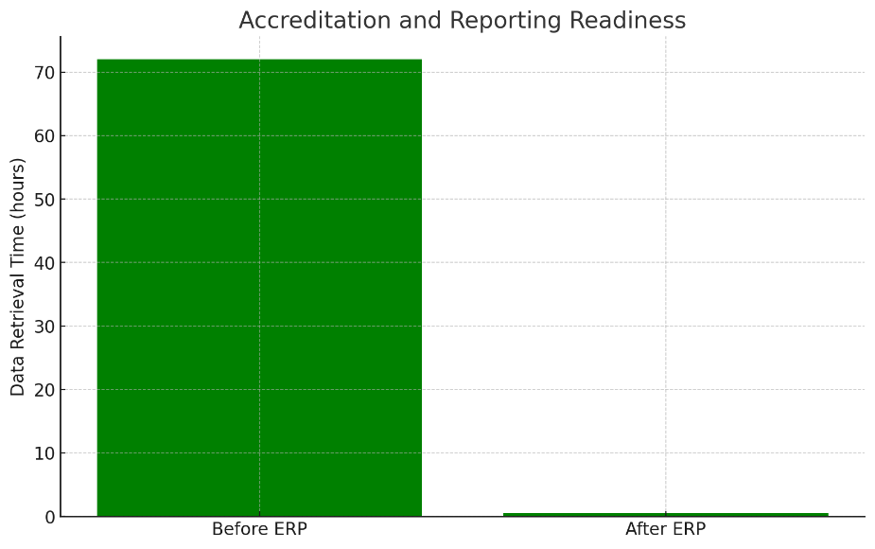

7. Conclusion
We were able to make the ERP System in AMET University to integrate most of the important functions in academics and administration. The system Increased the effectiveness, clarity, and accountability of the institution. Now, the institution is ready to use advance technologies such as predictive analytics, academic monitoring, IoT-based campus management, and better firewall. The paper shows that a planned, step-by-step approach to ERP deployment can greatly change the operations of HEIs.

References
[16]Sivakumar Dhandapani “An Advent Load Balancing Transmission Measures In Cloud Computing”
International Journal of Research in Science and Technology (ISSN 2394 – 9554) vol 11, no.2: April-June 2024
[17]Santhosh, Tony & Dhandapani, Sivakumar. (2023). Relative Analysis of VANET Algorithms. 1-7.
10.1109/GCITC60406.2023.10426405.
[18]Santhosh, Tony & Dhandapani, Sivakumar. (2019). Hybridization of Monarch Butterfly and Grey Wolf Optimization for Optimal Routing in VANET. International Journal of Engineering and Advanced Technology.
9. 3049-3060. 10.35940/ijeat.B4112.129219.
[19]SriVenkateswaran, C. & Dhandapani, Sivakumar. (2019). Secure cluster-based data aggregation in wireless sensor networks with aid of ECC. International Journal of Business Information Systems. 31. 153.
10.1504/IJBIS.2019.100277.
[20]Loyd, B. & Dhandapani, Sivakumar. (2015). A case study on VoIP over WMN based architecture for future e-governance of Indian rural areas. 66-71. 10.1109/TIAR.2015.7358533.

